SYSTEM REQUIRMENT SPECIFICATIONS FOR
MAIL ARCHIEVER

PURPOSE OF THE SYSTEM
This project is developed to create a Mail Server. A Mail server is an application which used to send and receive mails. This type of application needs to manage mails send by registered users.

The project Entitled “MAIL ARCHIEVER” deals with identifying the clients to send and receive mail. This project is about developing a web based Mail Archiever connecting to a windows Server running a Mail Server. This utility will allow multiple clients to login through the login page and have personalized mail information, enabling them to send and receive mails. Each user willing to avail the services offered by the mail server application should sign in as a user before he can send or receive mails. This is made possible by prompting each user to enter his user-id and password before he can send or view his mails. This project has Inbox, compose and address list. E-mail is one of the most common and reliable methods of communication for both personal and business purposes. It also plays an important role in each and every Web site. This role will be in the type of automated e-mails from the server after posting information from a form.

A message has to be composed in compose box. This message is stored in inbox directory of receiver. This file should be combination of the sender’s user-id and sub. The file transmitted is moved from sender compose to receiver inbox. The recipient can view the message by selecting the appropriate file no. This is also provision for the replying and deleting the message. This utility also enables users, working under different login names to communicate with each other.

We can send files through attachments. In this we attach the files to the mail by browsing option. From desktop or any drive we can select files and we will attach them to the mail that we want to send presently and then we send them to the receiver.

The software is fully integrated with CRM (Customer Relationship Management) as well as CMS (Content Management System) solution and developed in a manner that is easily manageable, time saving and relieving one from manual works.

Mail Server Main Features
- Supports sending and receiving email via web browser.
- Supports sending and receiving email via Internet.
- Allows user to register mailbox, change password, and modify user info via web browser.
- Allows administrator to create, delete, and disable user's mailbox and set mailbox size.
- Supports administrator sending email to multiple users at a time.
- Can generate user mailbox info report.
- Can backup all the emails sent by mail server.
- Provides detailed log file.
- Supports mail group.
- Invalidate user login on inactive for more than 3 times
- Address book capability
- Mark mails as Junk
- Apply Label to Mail
- Organize mails in Logical Folders

PROBLEMS IN THE EXISTING SYSTEM:
- The existing system is manual system. Needs to be converted into automated system.
- Risk of mismanagement of data.
- Less Security.
- No proper coordination between different Applications and Users.
- Fewer Users - Friendly.
- Accuracy not guaranteed.
- Not in reach of distant users.

SOLUTION OF THESE PROBLEMS
The development of the new system contains the following activities, which try to automate the entire process keeping in view of the database integration approach.
- User friendliness is provided in the application with various controls.
- The system makes the overall project management much easier and flexible.
- There is no risk of data mismanagement at any level while the project development is under process.
- It provides high level of security with different level of authentication.
- Users from any part of the world can make use of the system.
- New system will process accurate results.
- New system will be much better in performance as compared to existing one.

STUDY OF THE SYSTEM
The Project is mainly based on features like (Member registration feature/ Sending and Receiving mails feature/ Integrated Security feature etc.).
Developing a Mail Server:
The mail Server can be developed in Microsoft Technologies. In ASP.Net, we have separate API for mail operations. All Mail Classes with methods are defined under System.Net.Mail Namespace. By making use of this API and by adding SQL Server Database support, we can easily obtain the features, A Mail Server requires.

Number of Modules
The system after careful analysis has been identified to be presented with the following modules:

The modules involved are:
- Member registration Module:
- Member can register and sign in here. For registration, member has to provide personal details, address details, employment details, account details and they have to agree with policies.
- Member can sign in by providing their account details (Username and password).
- Sending and Receiving mails:
- By making use of this module, Members can send/receive/view mails. Many features have been provided to members so that they can 1) manage (view/ edit/ delete) their mails, 2) forward mails, 3) send attachments, 4) send group mail, manage mails in folders etc.
- Integrated Security Module:
- This module is made is provide security features to the application.
- Admin Module:
- Admin is a super user and hence responsible for a) Site Maintenance, b) Members Management, c) Mails management and d) Generate various reports.
- Login/Logout Date & Time Tracking Module: Admin can view the Login/Logout time of User. Whenever the user login/logout then Current Date & Time will be stored to view for Admin.
- Address book Maintenance: Here user can maintain the address book for own friend with all Address Contact Info, Birthday, and Marriage Anniversary etc.
- CMS (content Management System) Integration: Using CMS tool we can customize the mail the message with all formatting features like below.
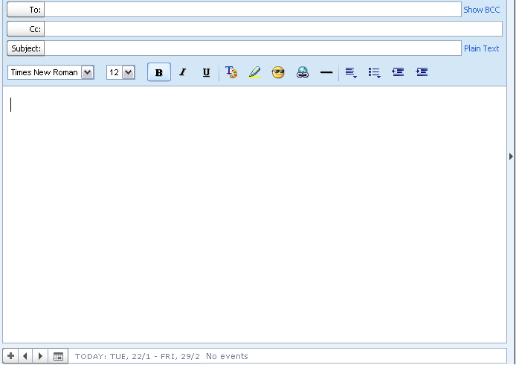

INPUTS & OUTPUTS

The main inputs, outputs and major functions of the system are as follows.
Inputs:
Member Registration details:
Registration module is responsible for member registration and login. While registration, member will be prompted for his 1) login account details (username, password, hint question, answer), 2) his personal details, and 3) his contact address
At time of sign in, Member has to provide username and password.
In Message compose box, Member has to provide Message to send with Email-ID (to whom message has to be sent.).

Outputs:
- On successful registration, member will be provided confirmation mail.
- On successful signing in, member will be placed to My Account page.

SDLC METHODOLOGIES
This document play a vital role in the development of life cycle (SDLC) as it describes the complete requirement of the system. It means for use by developers and will be the basic during testing phase. Any changes made to the requirements in the future will have to go through formal change approval process.
SPIRAL MODEL was defined by Barry Boehm in his 1988 article, “A spiral Model of Software Development and Enhancement. This model was not the first model to discuss iterative development, but it was the first model to explain why the iteration models.
As originally envisioned, the iterations were typically 6 months to 2 years long. Each phase starts with a design goal and ends with a client reviewing the progress thus far. Analysis and engineering efforts are applied at each phase of the project, with an eye toward the end goal of the project.
The steps for Spiral Model can be generalized as follows:
- The new system requirements are defined in as much details as possible. This usually involves interviewing a number of users representing all the external or internal users and other aspects of the existing system.
- A preliminary design is created for the new system.
- A first prototype of the new system is constructed from the preliminary design. This is usually a scaled-down system, and represents an approximation of the characteristics of the final product.
- A second prototype is evolved by a fourfold procedure:
- Evaluating the first prototype in terms of its strengths, weakness, and risks.
- Defining the requirements of the second prototype.
- Planning an designing the second prototype.
- Constructing and testing the second prototype.
- At the customer option, the entire project can be aborted if the risk is deemed too great. Risk factors might involved development cost overruns, operating-cost miscalculation, or any other factor that could, in the customer’s judgment, result in a less-than-satisfactory final product.
- The existing prototype is evaluated in the same manner as was the previous prototype, and if necessary, another prototype is developed from it according to the fourfold procedure outlined above.
- The preceding steps are iterated until the customer is satisfied that the refined prototype represents the final product desired.
- The final system is constructed, based on the refined prototype.
- The final system is thoroughly evaluated and tested. Routine maintenance is carried on a continuing basis to prevent large scale failures and to minimize down time.

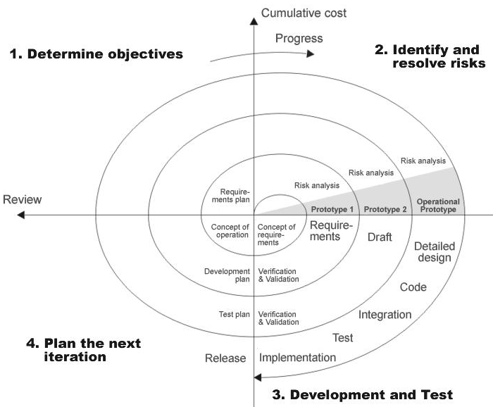

Fig 1.0-Spiral Model

The developer is responsible for:
- Developing the system, which meets the SRS and solving all the requirements of the system?
- Demonstrating the system and installing the system at client's location after the acceptance testing is successful.
- Submitting the required user manual describing the system interfaces to work on it and also the documents of the system.
- Conducting any user training that might be needed for using the system.
- Maintaining the system for a period of one year after installation.

INPUT DESIGN

Input design is a part of overall system design. The main objective during the input design is as given below:
- To produce a cost-effective method of input.
- To achive the highest possible level of accuracy.
- To ensure that the input is acceptable and understood by the user.

INPUT STAGES:
The main input stages can be listed as below:
- Data recording
- Data transcription
- Data conversion
- Data verification
- Data control
- Data transmission
- Data validation
- Data correction

INPUT TYPES:
It is necessary to determine the various types of inputs. Inputs can be categorized as follows:
- External inputs, which are prime inputs for the system.
- Internal inputs, which are user communications with the system.
- Operational, which are computer department’s communications to the system?
- Interactive, which are inputs entered during a dialogue.

INPUT MEDIA:
At this stage choice has to be made about the input media. To conclude about the input media consideration has to be given to;
- Type of input
- Flexibility of format
- Speed
- Accuracy
- Verification methods
- Rejection rates
- Ease of correction
- Storage and handling requirements
- Security
- Easy to use
- Portabilility

Keeping in view the above description of the input types and input media, it can be said that most of the inputs are of the form of internal and interactive. As Input data is to be the directly keyed in by the user, the keyboard can be considered to be the most suitable input device.

OUTPUT DESIGN

Outputs from computer systems are required primarily to communicate the results of processing to users. They are also used to provide a permanent copy of the results for later consultation. The various types of outputs in general are:
- External Outputs, whose destination is outside the organization,
- Internal Outputs whose destination is with in organization and they are the
- User’s main interface with the computer.
- Operational outputs whose use is purely with in the computer department.
- Interface outputs, which involve the user in communicating directly with

OUTPUT DEFINITION
The outputs should be defined in terms of the following points:
- Type of the output
- Content of the output
- Format of the output
- Location of the output
- Frequency of the output
- Volume of the output
- Sequence of the output

It is not always desirable to print or display data as it is held on a computer. It should be decided as which form of the output is the most suitable.

For Example
- Will decimal points need to be inserted
- Should leading zeros be suppressed.
OUTPUT MEDIA:
In the next stage it is to be decided that which medium is the most appropriate for the output. The main considerations when deciding about the output media are:

- The suitability for the device to the particular application.
- The need for a hard copy.
- The response time required.
- The location of the users
- The software and hardware available.

Keeping in view the above description the project is to have outputs mainly coming under the category of internal outputs. The main outputs desired according to the requirement specification are:

The outputs were needed to be generated as a hot copy and as well as queries to be viewed on the screen. Keeping in view these outputs, the format for the output is taken from the outputs, which are currently being obtained after manual processing. The standard printer is to be used as output media for hard copies.

CONTEXT DIAGRAM
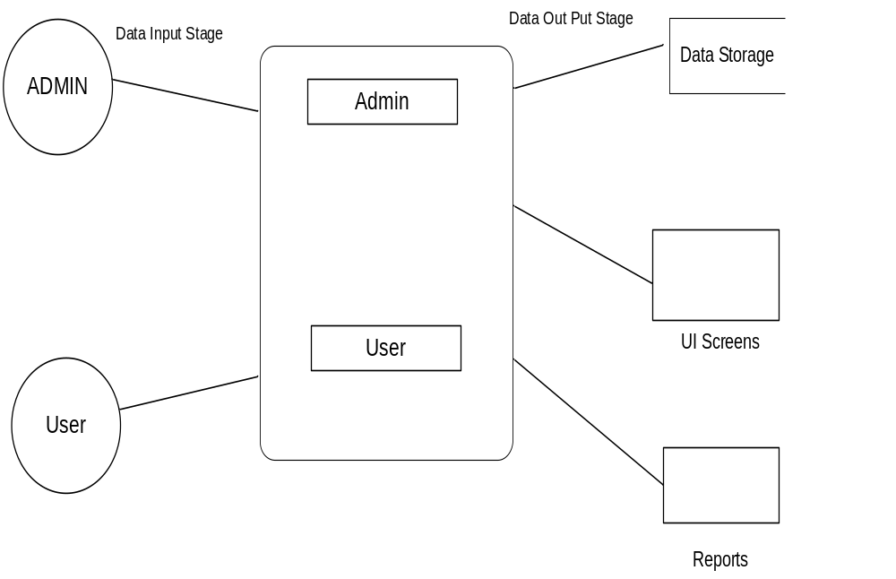
APPLICATION DEVELOPMENT:
N-Tier Applications:
N-Tier Applications can easily implement the concepts of Distributed Application Design and Architecture. The N-Tier Applications provide strategic benefits to Enterprise Solutions. While 2-tier, client-server can help us create quick and easy solutions and may be used for Rapid Prototyping, they can easily become a maintenance and security night mare
The N-tier Applications provide specific advantages that are vital to the business continuity of the enterprise. Typical features of a real life n-tier may include the following:
- Security
- Availability and Scalability
- Manageability
- Easy Maintenance
- Data Abstraction
The above mentioned points are some of the key design goals of a successful n-tier application that intends to provide a good Business Solution.
Definition:
Simply stated, an n-tier application helps us distribute the overall functionality into various tiers or layers:
- Presentation Layer
- Business Rules Layer
- Data Access Layer
- Database/Data Store
Each layer can be developed independently of the other provided that it adheres to the standards and communicates with the other layers as per the specifications.
This is the one of the biggest advantages of the n-tier application. Each layer can potentially treat the other layer as a ‘Block-Box’.
In other words, each layer does not care how other layer processes the data as long as it sends the right data in a correct format.

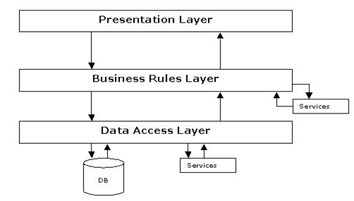
Fig 1.1-N-Tier Architecture
- The Presentation Layer:
Also called as the client layer comprises of components that are dedicated to presenting the data to the user. For example: Windows/Web Forms and buttons, edit boxes, Text boxes, labels, grids, etc.
- The Business Rules Layer:
This layer encapsulates the Business rules or the business logic of the encapsulations. To have a separate layer for business logic is of a great advantage. This is because any changes in Business Rules can be easily handled in this layer. As long as the interface between the layers remains the same, any changes to the functionality/processing logic in this layer can be made without impacting the others. A lot of client-server apps failed to implement successfully as changing the business logic was a painful process.
- The Data Access Layer:
This layer comprises of components that help in accessing the Database. If used in the right way, this layer provides a level of abstraction for the database structures. Simply put changes made to the database, tables, etc do not affect the rest of the application because of the Data Access layer. The different application layers send the data requests to this layer and receive the response from this layer.
- The Database Layer:
This layer comprises of the Database Components such as DB Files, Tables, Views, etc. The Actual database could be created using SQL Server, Oracle, Flat files, etc.
In an n-tier application, the entire application can be implemented in such a way that it is independent of the actual Database. For instance, you could change the Database Location with minimal changes to Data Access Layer. The rest of the Application should remain unaffected

PERFORMANCE REQUIREMENTS:

Performance is measured in terms of the output provided by the application. Requirement specification plays an important part in the analysis of a system. Only when the requirement specifications are properly given, it is possible to design a system, which will fit into required environment. It rests largely in the part of the users of the existing system to give the requirement specifications because they are the people who finally use the system. This is because the requirements have to be known during the initial stages so that the system can be designed according to those requirements. It is very difficult to change the system once it has been designed and on the other hand designing a system, which does not cater to the requirements of the user, is of no use.
The requirement specification for any system can be broadly stated as given below:
- The system should be able to interface with the existing system
- The system should be accurate
- The system should be better than the existing system
The existing system is completely dependent on the user to perform all the duties.

